**OBJECT ORIENTED PROGRAMMING**

**LAB# 05 TASKS**

## **Understanding the implementation of Static Classes & Members**

1.Write a program to calculate area of rectangle by using static method.Use parameterized constructor to assign width and height to the instance. Use Output area method which uses the static method to calculate the area.

1. Write a program to display Name, Enrollment Number, University Name and ,Semester of students that are from same university and semester using static fields and methods.(Hint: first set the university name and semester as follows:



Then use static variable counter to get unique roll numbers as follows:

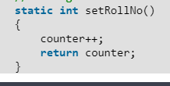

3.Write a static method called printNTimes that takes an integer n and a string (in that order) as its parameters and prints the string n times. For example

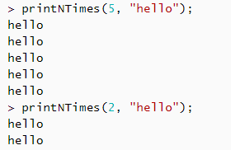

4.Write a static method called insult that has two paramaters, a String which represents a person’s name and an integer which represents the persons age. This  
method should create and **return** a String which is a personal insult based on the value of the argument age that was passed. Use the following age cuttoffs (or variations of your choosing) for creating your insults:

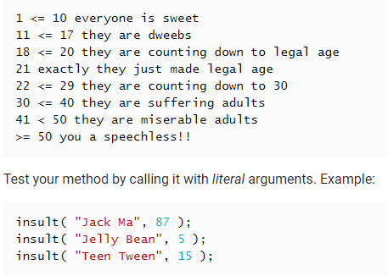

5.Write a static method called greetMe that greets you. The method should issue a prompt asking for your name, display a polite (or not so polite) greeting message and then prompt you to enter your age.